Our Lady School Spirit Wear | ORDER FORM
FoR:  Student Name: _______________________ | Grade: _______

ITEM | DESCRIPTION |  |  |  | Size | Price | QTY | TOTAL
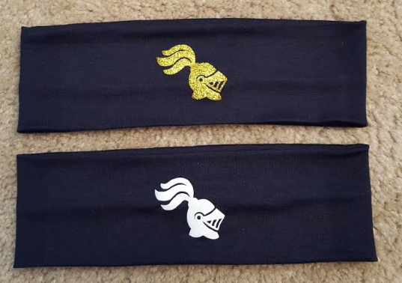 | 2.5 Inch Navy Headband |  |  |  | Gold  White | $7
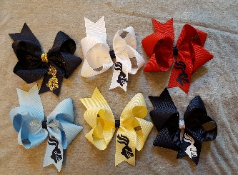 | Boutique bow with knight ~5” across.  Navy/glitter gold, White/navy, Red/navy  Lt. blue/navy, Yellow/navy, Navy/white. |  |  |  | Navy/gold  White/navy  Red/navy  Lt. Blue/navy  Yellow/navy  Navy/white | $7
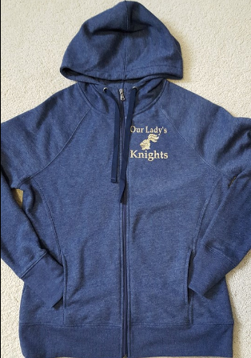 | Ladies Heather Navy Blue  fitted full zip sweatshirt with glitter gold design. |  |  |  | Large  XLarge | $25
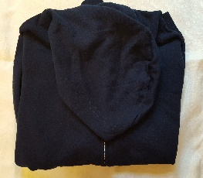 | Ladies Navy Blue full zip Sweatshirt, fitted, t-shirt type material. Glitter gold design not shown but will be applied when ordered. |  |  |  | Small  Medium  Large  X-Large  XXL | $25
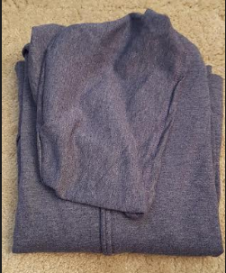 | Ladies Hanes, Heather Navy, full zip sweatshirt. Glitter gold or white design not shown, but will be applied to sweatshirt when ordered. |  |  |  | Small  Medium  Large  X-Large  XX-Large | $25
Personalize the back of the sweatshirt with a name in glitter gold lettering. | Name requested, please print clearly.  ________________________ |  |  |  | One size | $6
Please wash clothes inside out and hang to dry. |  | REvised 8/11/18
Please make checks payable to:  Our Lady School |  | TOTAL
Items provided by
Hannah’s Hairbows

 |  |  |  | Sign |  |  |  | Date

